**Data Manipulation Methodology**

Segregation:

* The EEG samples are segregated into alert and drowsy states for all the subjects based on the 'substate' variable.
* The segregated alert and drowsy data are saved into new '.mat' files.

Manipulating alert and drowsy states data:

* The alert data is loaded and transposed, concatenating all EEG samples into a new DataFrame.
* Similar manipulation is performed on the drowsy state data.

Creating Combined Dataset:

* The manipulated alert and drowsy datasets are concatenated row-wise into a new DataFrame.

**Data Manipulation Result**

The initial EEG dataset contained 2022 samples, each with 30 channels and 384 data points, recorded over 3 seconds at a sampling rate of 128Hz from 11 subjects. The shape of the dataset was (1011, 384, 30) for both alert and drowsy states. After manipulation, the dataset has transformed into a flat structure with 776448 rows and 31 columns where the additional column represented the 'substate' variable, which contains alert (0) and drowsy (1) states. This manipulation resulted in a new DataFrame for both alert and drowsy states, each with a shape of (388224, 31).

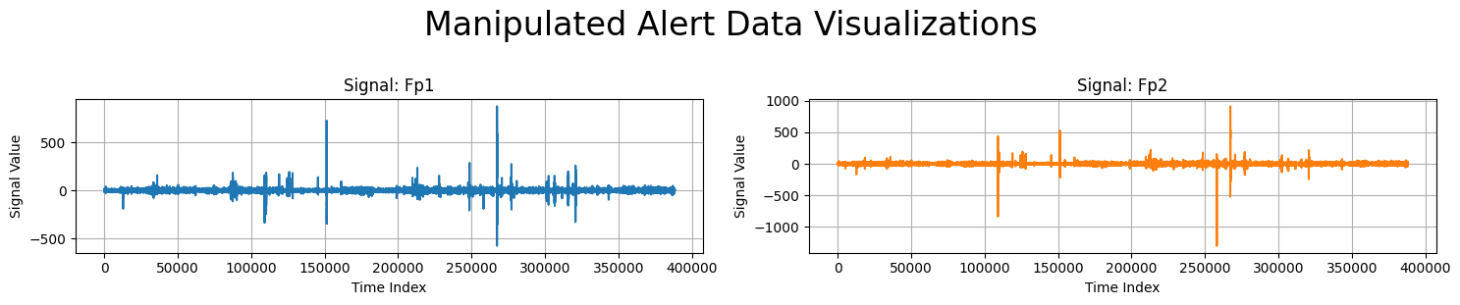

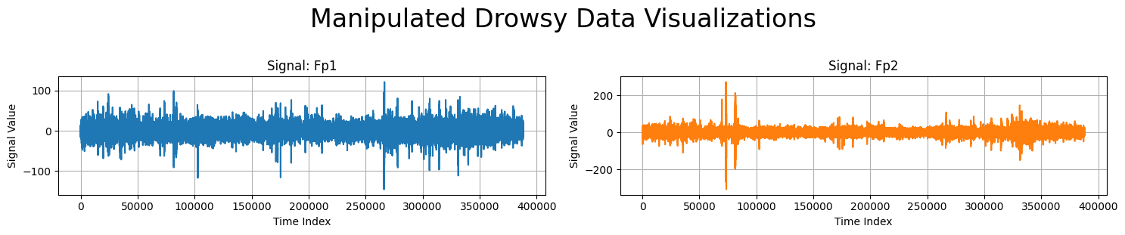

**Figure:** Visualization of Manipulated Alert and Drowsy Data for Signal Fp1 and Fp2

**Manipulated Alert Data**

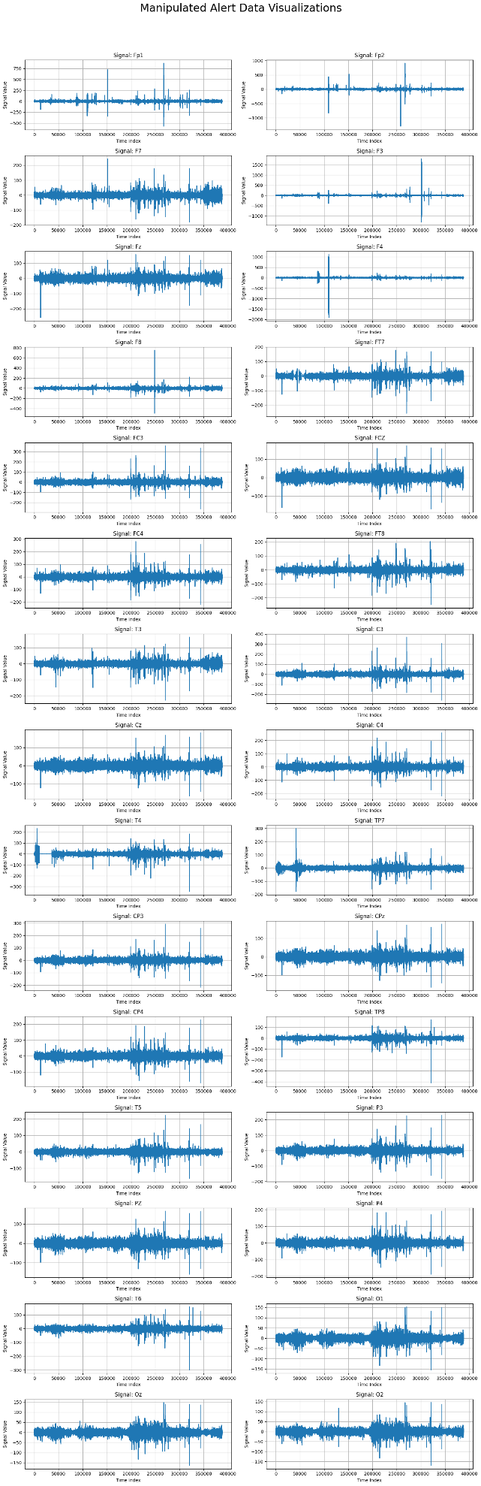

**Manipulated Drowsy Data**

